Lab assignment 5(XML)

1.Create xml file with root element as music with its children song and sub children( name, artist, playtime).
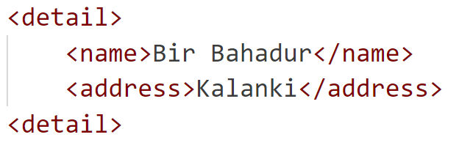
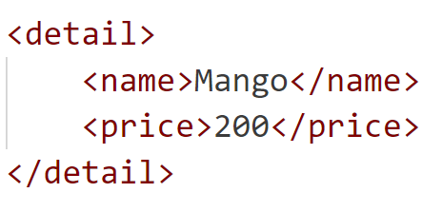
2. Create a xml file to join two xml files with same element names. Use xml namespace.

3. Write internal and external DTD to describe "mail" as a root element and "to", "from", and "subject", and "message" as child elements.
4. Write DTD script demonstrating use of different DTD operators.
5.Write DTD script demonstrating use of different DTD attribute values.
6. Write valid DTD for following xml
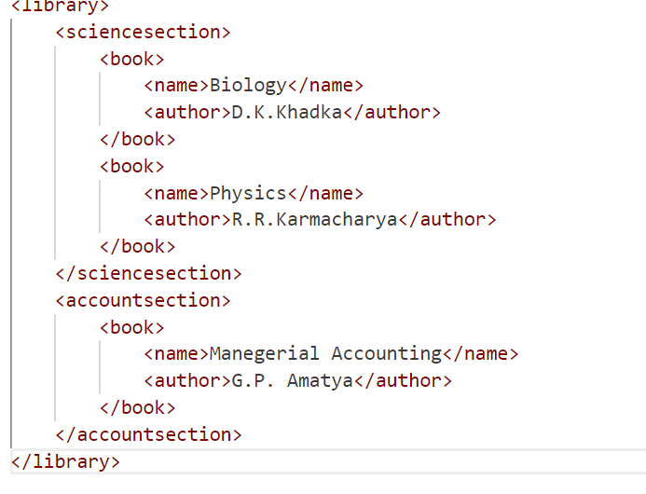
7. Write XSD document for xml document with elements
<person>
<student>
<name>…….</name>
<age>……</age>
<pincode>….</pincode>
</student>
</person>
- Rules to set:
- Name must allow only lowercase characters
- Age must be between 16-18
- Pincode must allow 4 digits only

8.Demonstrate use of XSLT for xml files mentioned in question no.2 in tabular format.
9. Perform xquery operation on same xml file to display items whose price is 200.

